Self Service Punching
Upon logging into iSolved, an employee can immediately create a punch by using the employee self-service punch option location at the top left side of the page, as seen below. In this menu, a punch can be created via two different methods:

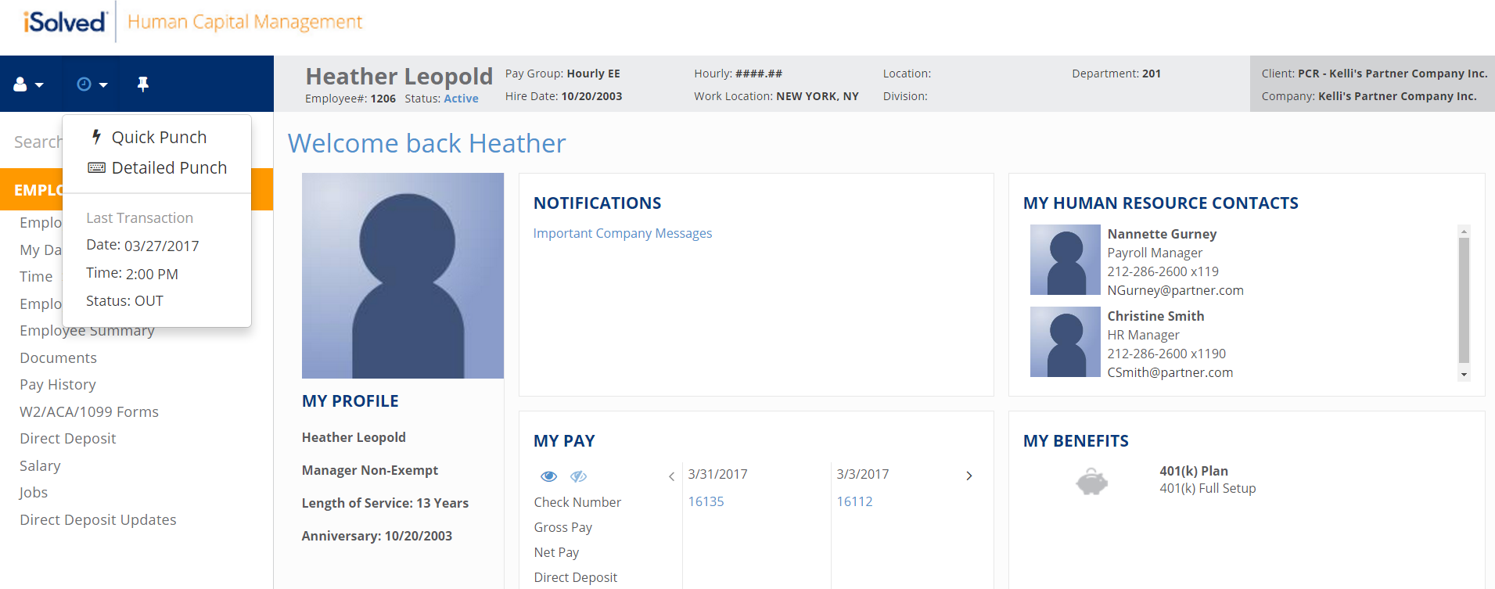Quick Punch
- When a user clicks on the Quick Punch option, iSolved will immediately create a punch for the current date and time for the user, without the option to add punch notes or other punch options.
- Once the punch is created, the user will see a confirmation at the top of the iSolved page as shown above.

Requesting Time Off
Users have the ability to submit a time off request from the time card screen, by selecting the request time off button on the blue action bar.
- Select the Request Time Off button from the action bar
- Enter the time off request details
  - Select Absence Policy
  - Select the From and To Dates
  - Enter Start time for the absences
  - Update corresponding dates of the week
  - Enter the numbers of hours per day you are requesting
- Review the Projected Balances
  - After Time off Request: What the employee balance will be after the request is made. This is simply the current balance minus the request.
    - Note: This does not take any future awards/pending/limits into consideration after the date of the request.
  - Current Plan Year: Balance will take all current requests/future awards/pending approvals/limits into consideration to the end of the current plan year.
  - Next Plan Year: Balance will take all current requests/future awards/pending approvals/limits/carryover into consideration through the end of the next plan year.
